Q2
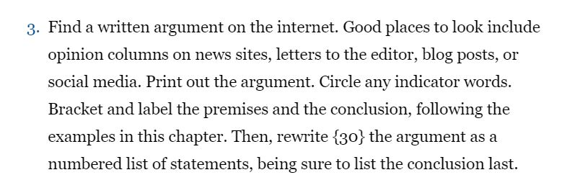

Chart
- {premises}
- Indicator words
To the Editor:
In 1855, Nathaniel Hawthorne wrote to his publisher, “America is now wholly given over to a damned mob of scribbling women.” Although he was referring specifically to sentimental novelists, his letter expressed the larger {belief that women’s writing was not worth reading or publishing}¹, that {their words and ideas didn’t matter}², and that {their work was, to use the language of Hawthorne, “trash.”}³
As a historian, I see this playing out not only in the antebellum period, but also in the post-war era when I read letters to the editor. As I scan through various national newspapers, day after day, year after year, I find myself hoping that someday, eventually, {women will be represented proportionally.}⁴ I am always disappointed; {they always skew male.}⁵
Perhaps Hawthorne’s disdain for scribbling women is not such distant history.
This problem is especially concerning because unlike an Op-Ed — where the writer presumably has some expertise in the subject matter — {anybody can submit a letter to the editor}⁶. It is, I’d argue, the most democratic section of the paper because children and adults, billionaire philanthropists and minimum-wage workers, and {people of all genders can contribute}⁷. {Each has an equal opportunity to express her or his thoughts and participate in a robust debate in the public sphere}⁸. Therefore, I’m troubled that {in 2019, The New York Times struggles to find women’s letters that are worthy of publication}⁹.
When I first inquired as to why so few women were writing, I was told that {there aren’t formal statistics on the number of women submitting letters, but that a large majority come from men}¹⁰. Gail Collins provided a similar explanation when she became the first woman editor of the editorial page at The Times in 2001 and started looking into this problem. She found that in letters to the editor and Op-Ed submissions, “{the preponderance of men was off the charts.”}⁹
But still, causality remains murky. {Are women not writing because they don’t see themselves represented? What role does implicit bias play?}¹⁰ In the absence of formal research, it’s hard to know.
The Times could {put in place a quota for women’s letters}¹¹, {ensuring that the number of women published each week is roughly proportional to the number of women in the population}¹². But given the overwhelming backlash against affirmative action, {I am not optimistic that this is a realistic possibility}¹³.

So, while I would like to see more institutional changes, in the short term I want to {encourage women to write more letters to the editor.}¹⁴ The poet Audre Lorde described writing as a political act, the way “{we predicate our hopes and dreams toward survival and change}¹⁵.”
Similarly, submitting a letter to the editor says that in a society that refuses to acknowledge your full humanity, {you insist on it}¹⁶. It is {asserting that your ideas and words deserve an audience in a world that has historically devalued them}¹⁷. It is {accepting that you most likely will never receive external validation for your efforts}¹⁸ save for an automated email thanking you for your letter.
{You will never know if your letter wasn’t published because you were Kimberly and not Karl}¹⁹, or if {your letter was boring}²⁰, or if {it had absolutely nothing to do with the merits of what you wrote}²¹. As Ta-Nehisi Coates reflected in “We Were Eight Years in Power”: “{My reasons for writing had to be my own, divorced from expectation}²². {There would be no reward}²³.”

I used to think the {reward would be the individual accomplishment of an editor selecting my letter as worthy of publication}²⁴. But now {I know the reward would be for tomorrow and the next day and the next, to open up The New York Times}²⁵ letters pages in any national newspaper — and {to see nasty, scribbling women from all over the country sharing their ideas and having their thoughts equally represented.}²⁶
KIMBERLY PROBOLUS
Washington
The writer is a Ph.D. candidate in American studies at George Washington University.

- A belief that women’s writing was not worth reading or publishing
- Their words and ideas didn’t matter
- Their work was, to use the language of Hawthorne, “trash”
- Women will be represented proportionally
- They always skew male.
- Anybody can submit a letter to the editor
- People of all genders can contribute
- Each has an equal opportunity to express her or his thoughts and participate in a robust debate in the public sphere`
- In 2019, the new york times struggles to find women’s letters that are worthy of publication
- There aren’t formal statistics on the number of women submitting letters, but that a large majority come from men
- Put in place a quota for women’s letters
- Ensuring that the number of women published each week is roughly proportional to the number of women in the population
- I am not optimistic that this is a realistic possibility
- Encourage women to write more letters to the editor
- We predicate our hopes and dreams toward survival and change.
- You insist on it
- Asserting that your ideas and words deserve an audience in a world that has historically devalued them
- Accepting that you most likely will never receive external validation for your efforts
- You will never know if your letter wasn’t published because you were Kimberly and not Karl
- Your letter was boring
- It had absolutely nothing to do with the merits of what you wrote
- My reasons for writing had to be my own, divorced from expectation
- There would be no reward
- The reward would be the individual accomplishment of an editor selecting my letter as worthy of publication
- I know the reward would be for tomorrow and the next day and the next, to open up the new york times
- To see nasty, scribbling women from all over the country sharing their ideas and having their thoughts equally represented

Q3
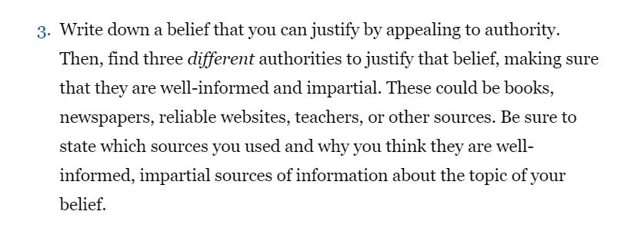
While the existence of unidentified flying objects (UFOs) is controversial, I do believe they do exist. UFOs cannot be identified using conventional means, raising fears of the existence of aliens. Recently, the Department of Defense released videos of UFOs confirming that the observed objects could not be identified. Source: New York Times (https://www.nytimes.com/2020/04/28/us/pentagon-ufo-videos.html)
Scholars have also identified ways of proving the existence of UFOs as reported in the International Journal of Computer and Systems Engineering (https://pdfs.semanticscholar.org/c5e3/4d91c99d796b590291a4448ebc3ab71b7a62.pdf). The Institute of Electrical and Electronics Engineers has equally published numerous research works about the existence and track of UFOs (https://ieeexplore.ieee.org/abstract/document/8622418). My belief is founded on the reputation of the sources cited.
Q4
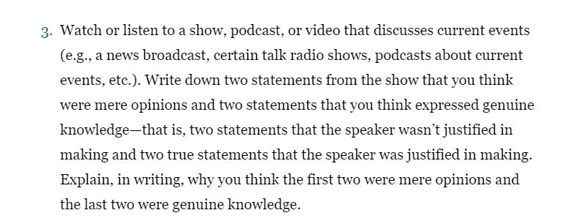
Podcast: The Telegraph https://podcasts.google.com/?feed=aHR0cHM6Ly9yc3MuYXJ0MTkuY29tL2Nvcm9uYXZpcnVzLXRoZS1sYXRlc3Q&episode=Z2lkOi8vYXJ0MTktZXBpc29kZS1sb2NhdG9yL1YwL1B2bU5iMExLQllMZ2JUZVpvT0JmVVN0SW1ncTR5VzVBdmZ1emVkZGlmLWs

- The number of people infected with Covid-19 during the first wave of the Chinese outbreak could be four times higher than official records suggest. This is a mere opinion as depicted by the word ‘could’. The infection could be higher or lower than the four times stated.
- This would also mean there was a cover-up. Again, this is also an opinion as the speaker is not sure whether the Chinese authorities covered up the confirmed cases of Covid-19 or not.
- Central workers in England and their families will be able to book coronavirus tests on the government website from Friday. – this expresses genuine knowledge as the speaker is reporting what the country’s health secretary had said.
- The government also said 18,000 people would be hired to help trace infection. – this is also genuine knowledge as it was the government’s stand at the time.

Q5

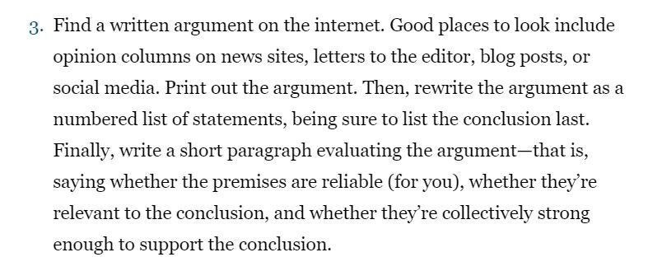

Source: The Guardian https://www.theguardian.com/commentisfree/2020/may/05/britain-emergency-planners-pandemic-government
Twelve years ago, I attended a conference on public health where a leading expert on pandemics introduced his talk by saying: “My task is to tell you things you don’t want to know and ask you to spend money you haven’t got on something you don’t think will happen.” He then went on to describe, in considerable detail, a scenario for a global pandemic that was eerily similar to the one we’re currently experiencing.
Fast-forward more than a decade, and it seems the UK government was badly prepared for the coronavirus pandemic. It’s not as if we didn’t have a prior warning that an event like this was a threat. Though Exercise Cygnus of 2016 remains shrouded in mystery, the government’s national risk register of civil emergencies has long put pandemics at the top of the list of risks the UK faces. In the 2017 register, a virus symbol sits in the top right-hand corner of a diagram of likelihood versus consequences. The UK’s strategy for managing a pandemic, meanwhile, was first published in 2011. But by 2014, government attention had turned away from pandemic preparation and back to counter-terrorism planning. And by 2016, planners in the UK were fully engaged in confronting the supply-chain disaster that would be Brexit, struggling to figure out how, for example, to boost the UK’s coffee supply.

Britain is experienced in planning for pandemics – so where is the emergency management of coronavirus? What we know so far about committees such as the scientific advisory group for emergencies (Sage) is that they appear to include no independent advisers on emergency planning and management. Expertise in medicine, virology, epidemiology, statistics, and global health are all represented. So are behavioral sciences and psychology. Yet there seems to be a prevailing sense that the coronavirus crisis is primarily a medical and epidemiological problem – and that other aspects are mere fallout.
This is not exactly true. Modeling the transmission of the virus, researching a vaccine, and procuring antiviral therapies are of course vitally important. But there is more to the coronavirus crisis than flattening its curve. The measures to contain the virus are relatively simple – physical distancing, testing, tracing, and isolation – but they are laden with consequences, both for society and individuals. Anticipating these effects and finding ways to mitigate them is the keystone of emergency planning.
The coronavirus crisis is complicated by the fact we are living in a highly interconnected world, where one event can have a ripple effect across the networks on which we all depend. Halting international travel, for example, has left food producers without seasonal migrant workers to harvest crops. But the arrival of seasonal workers from abroad in the future could lead to a second spike of infections, particularly if they live near one another. The issue of a second spike has already proved an issue in Singapore, previously lauded for its response to the virus. These are among the types of issues that emergency planners need to consider

Early attempts to deal with the crisis in the UK involved minimizing its significance to the public and frantically improvising in a vain attempt to catch up with the spread of the virus. If plans existed, there was an abyss between the decisions mandated by the government and the reality of how they played out on the ground. This underlines the fact that emergency planning must be a live effort. Reality does not stand still – so neither must the plans for dealing with an emergency. Planners should be able to foresee urgent needs and prioritize them, providing enough personal protective equipment to the care homes that have become hotspots for the virus, for example, and knowing in advance how to source such equipment in adequate quantities.
Numerous academics have presented fairly detailed scenarios for an influenza pandemic since 2008, which covered many of the social, economic, and public health consequences that we are now experiencing. But we still don’t have a clear idea about the recovery process, and what actions the government should take to help society and the economy to recover. Although we can look back to the 1918-1920 flu pandemic for an idea of how long this recovery process might take – and the challenges that this period will present – it’s difficult to apply this knowledge to the current crisis when so much has changed.
Emergency planning isn’t rocket science, but it’s distinctly challenging on many levels, involving intellectual, scientific, and practical decisions. Wherever an event can be foreseen, the plans should be based on a range of scenarios. Planning scenarios aren’t predictions of the future but rather systematic explorations of hypothetical situations, answering the question: “What if…?”
When disasters strike there should be three elements to the response: plans, procedures, and improvisation. We can imagine the planner as an orchestral conductor, directing the members of the orchestra to play their sheet music. It’s the conductor’s job to ensure the musicians play in harmony, and although improvisation can’t be eliminated, it should be reduced to a bare minimum. Emergency planners will be needed to identify and meet the novel challenges that coronavirus presents – both now and in the future. Never have they been needed more on critical advisory committees.
• David Alexander is professor of risk and disaster reduction at University
College London and vice-president of the Institute of Civil Protection and
Emergency Management
- The UK government was badly prepared for the coronavirus pandemic
- The government’s national risk register of civil emergencies has long put pandemics at the top of the list of risks the UK faces
- By 2014, government attention had turned away from pandemic preparation and back to counter-terrorism planning.
- Britain is experienced in planning for pandemics
- Where is the emergency management of coronavirus
- Measures to contain the virus are relatively simple – physical distancing, testing, tracing and isolation
- They are laden with consequences, both for society and individuals.
- Anticipating these effects and finding ways to mitigate them is the keystone of emergency planning.
- Early attempts to deal with the crisis in the UK involved minimizing its significance to the public
- Attempt to catch up with the spread of the virus.
- Planners should be able to foresee urgent needs and prioritize them,
- We still don’t have a clear idea about the recovery process
- Emergency planning involves intellectual, scientific and practical decisions
- There should be three elements to the response: plans, procedures, and improvisation
In my opinion, the argument is well-presented and the premises reliable. The author explains why he thinks the UK government was ill-prepared for the pandemic. While planning for pandemics started some years ago, the plans were interrupted by other occurrences such as terrorism and Brexit. The author concludes that the pandemic response should be comprised of plans, procedures, and improvisation.

Q6) Read the following essay by the philosopher Samuel; Scheffler: https://opinionator.blogs.nytimes.com/2013/09/21/the-importance-of-the-afterlife-seriously/
(Links to an external site.)
Briefly unpack the basic structure of his reasoning and explain whether or not you find it persuasive. You should also watch the brief video:
https://vimeo.com/109572679

In the essay, Scheffler paints pictures of the after-life to convince his audience why they should be responsible while they are alive. Scheffler explains that life would lose meaning if there was no after-life at all. Rather than believing in an after-life as an immortal, Scheffler believes that the lives of future generations matter most to him. I conclusion, Scheffler argues that living people depend on their descendants as much as the descendants depend on them. I find this essay persuasive because the assertions are factual. Life would indeed have no meaning if we knew the world would soon come to an immediate end.

Q7) Read the article and watch the embedded videos about the Canadian/First Nations activist Autumn Peltier:

"Many people don't think water is alive or has a spirit," the Anishinaabe girl from Wikwemikong First Nation told the diplomats gathered in New York City in her speech on World Water Day. "My people believe this to be true. Our water deserves to be treated as a human with human rights. We need to acknowledge our waters with personhood so we can protect our waters."
This is her full argument if we write it formally:
- Water is alive and has a spirit.
- Whatever is alive and has a spirit should be treated as having personhood.
- Therefore, water should be treated as having personhood.
- Whatever has personhood has rights.
- Therefore, water has rights.
- If water has rights, then we can better protect our waters.
- Therefore, we can better protect our waters.
Do you find her argument persuasive? In other words, do you think that it Is sound? Which of her premises are subject to Possible disagreement? Why?
https://www.cbc.ca/news/canada/autumn-peltier-un-water-activist-united-nations-1.4584871

I do not find this argument persuasive. the Anishinaabe girl argued that water has a spirit, which does not think it is sound. If truly water had a spirit, it would express similar attributes as humans such as feeling pain or showing sorrow. Besides, the chemical composition of water has since been established and does not support the assertion. Since this premise is not valid, the conclusion of water having rights is also invalid.

Q8

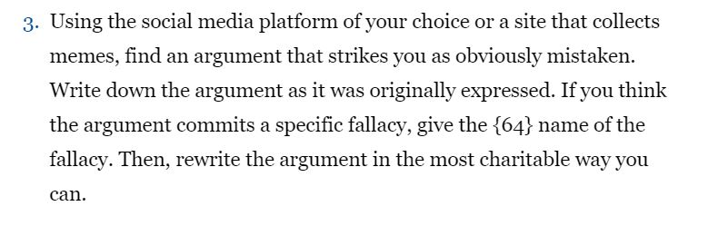
“Going to Africa. I hope I don’t get AIDS. Just kidding. I’m white!”. This tweet was sent by one Justine Sacco while en-route to Cape Town from New York. What followed was an unprecedented attack from angry Twitter users. One user even asserted that Sacco’s ignorance belonged to Fox News. I believe this tweet was racist and Sacco should have avoided the ‘being white’ part to read; “Going to Africa. I hope I don’t get AIDS. Just kidding.”
Q9
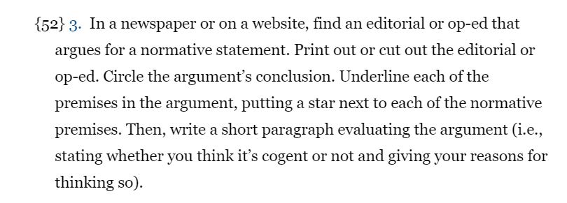
Source: https://www.nytimes.com/2019/08/31/opinion/sunday/world-leaders-penises.html
Chart: Conclusion
In as much of the world, economic liberalism is losing some of its luster in Australia. But perhaps more so than elsewhere, nationalist anti-immigrant politics is running aground, too. The times would seem to demand a renewed Australian conservatism, attentive to economic and social inequality, and comfortable enough with cultural diversity to search for political capital elsewhere.
In this editorial, Baird argues that Australia could soon witness an end to racism, especially in elections. This was in 2019 after new legislation that allowed refugees to vote was passed. Australia is predominantly a far-right country with the prominence of One Nation emboldened on them. However, with the Christchurch’s attack in New Zealand asserted to have been the result of racism, Australia needs to evaluate its stand. I believe this statement is cogent as there is a need to end racism and fascism.

